Appendices

Appendix A: Project Overview

The Job Portal App is a full-stack web application built using the MERN (MongoDB, Express.js, React.js, Node.js) stack. It connects job seekers and employers through an interactive and efficient platform. The system manages job listings, applications, and secure authentication for both users and employers.

Appendix B: Technologies Used

- Frontend: React.js with Vite JS framework
- Backend: Node.js with Express.js Framework MongoDB.
- Authentication: JWT (JSON Web Tokens), Bcrypt for password hashing
- Image Management: Cloudinary

Appendix C: System Requirements

- Node.js v20.9.0
- MongoDB Atlas account / local MongoDB server
- Cloudinary account for image storage
- Modern web browser (Chrome, Edge, or Firefox)

Appendix D: Installation & Configuration

- Clone the repository and navigate into the project directory.
- Install required NPM packages for both frontend and backend using npm install.
- Configure environment variables in a config.env file inside the backend/config folder.
- Start the backend using node server.js and frontend using npm run dev.
- Access the application at http://localhost:3000

Appendix E: Key Features

- Secure user authentication using JWT
- Job posting and application tracking
- Responsive and interactive user interface
- Employer dashboard for managing postings
- Secure data handling and cloud deployment

Appendix F: Contribution Guidelines

Developers can contribute by forking the repository, creating feature branches, committing changes, and submitting pull requests. Contributions help improve and expand the functionality of the platform.

Appendix G: Acknowledgment

This project demonstrates the practical application of full-stack web development principles using modern tools and frameworks.

Er Diagram –

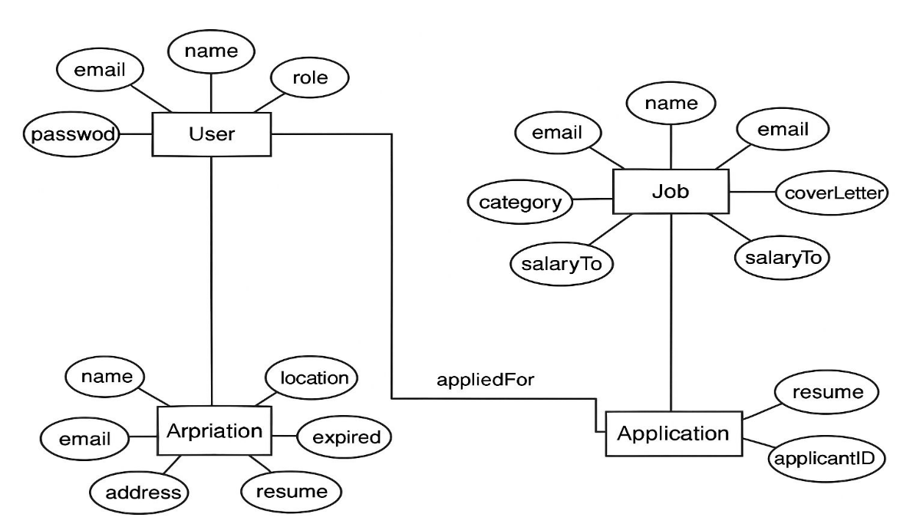

Project Screenshots –

Jobseeker

- Login
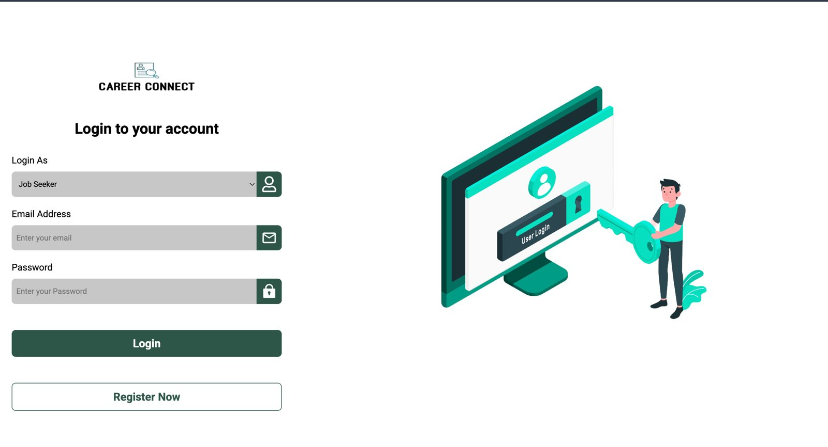
- Home Page
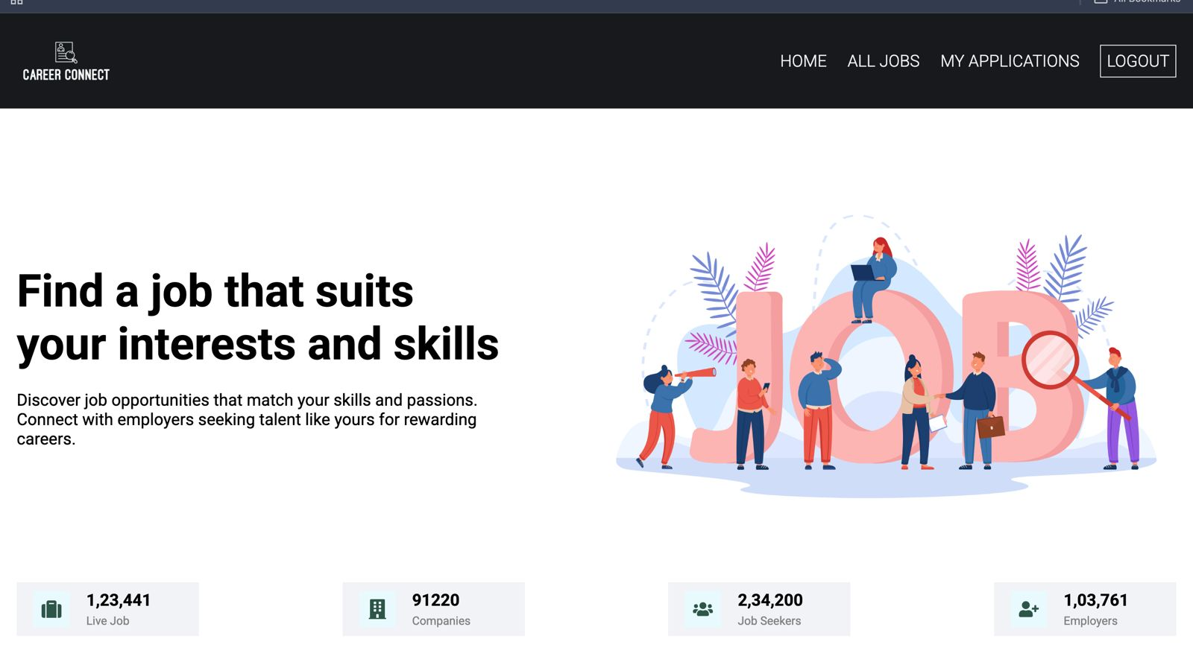

- All Jobs
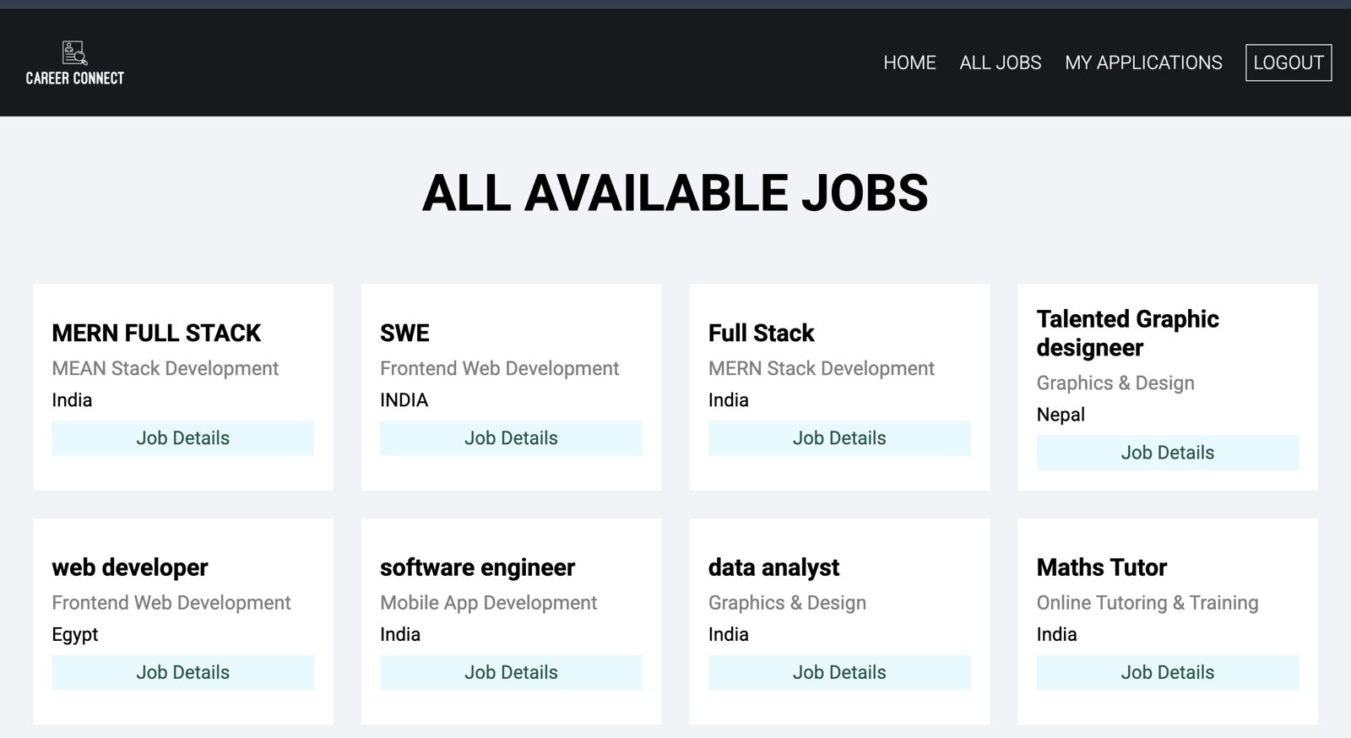

- Job Applied
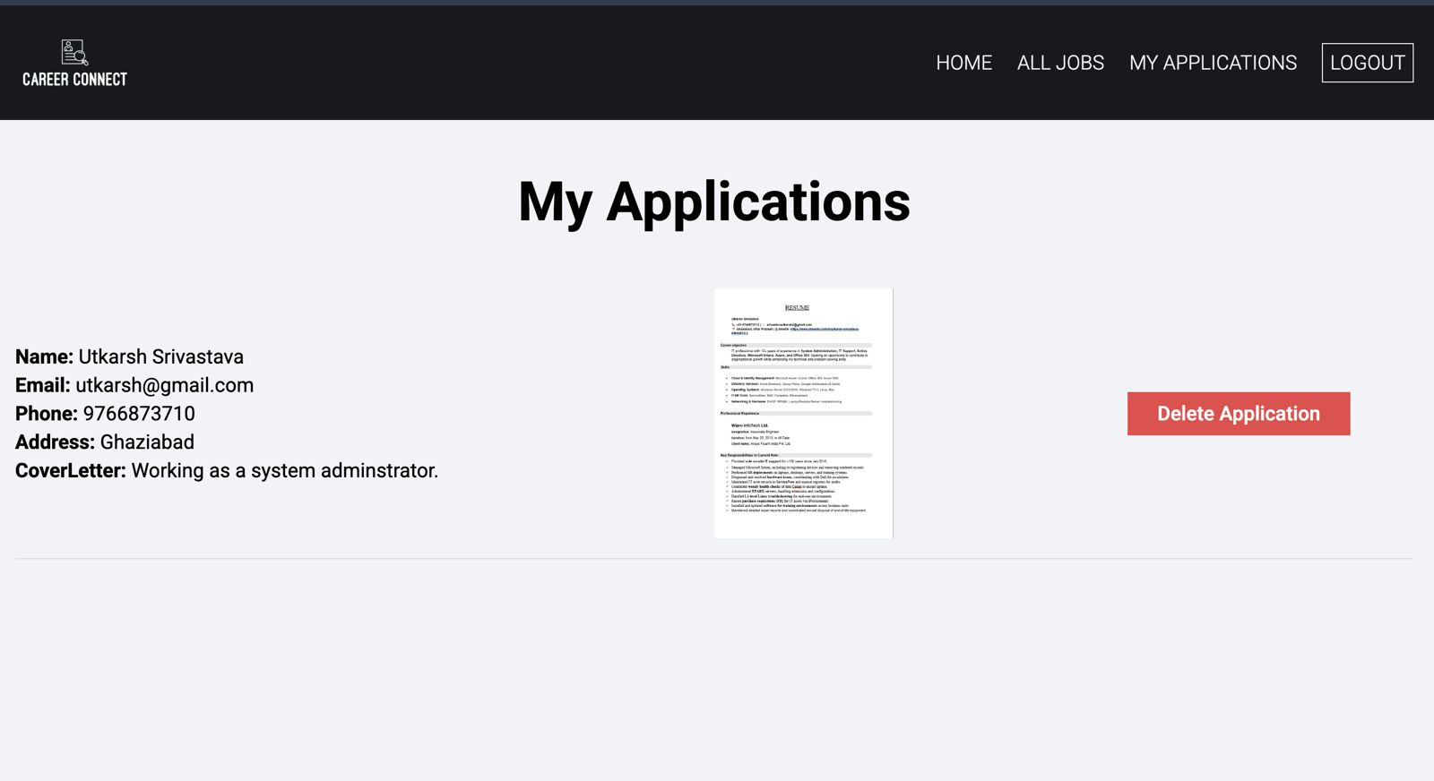

Recruiter

- Sign-Up

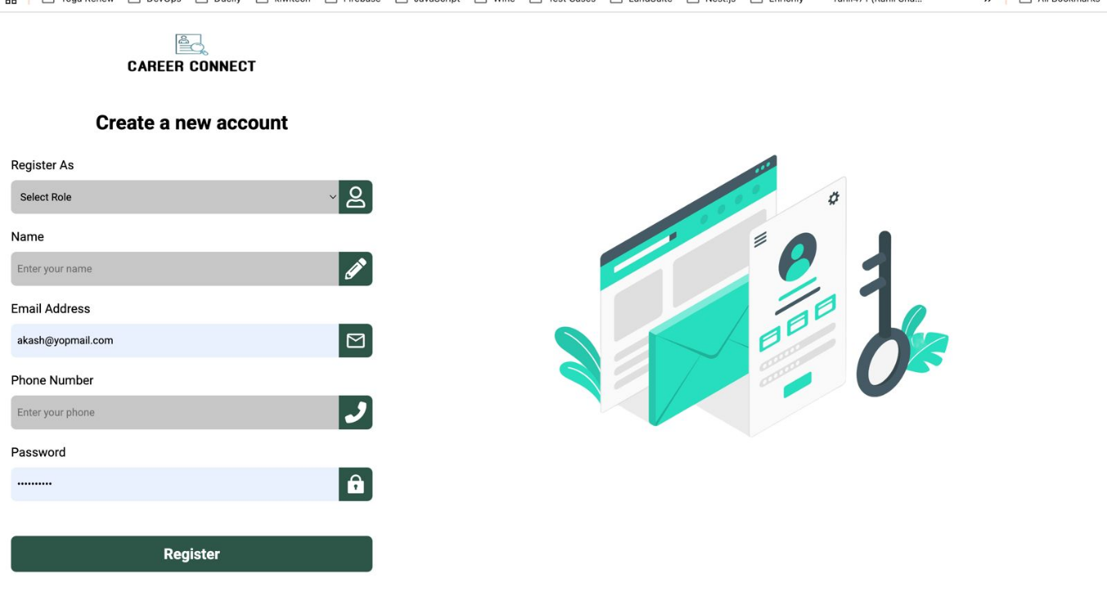

- Recruiter Job Posting
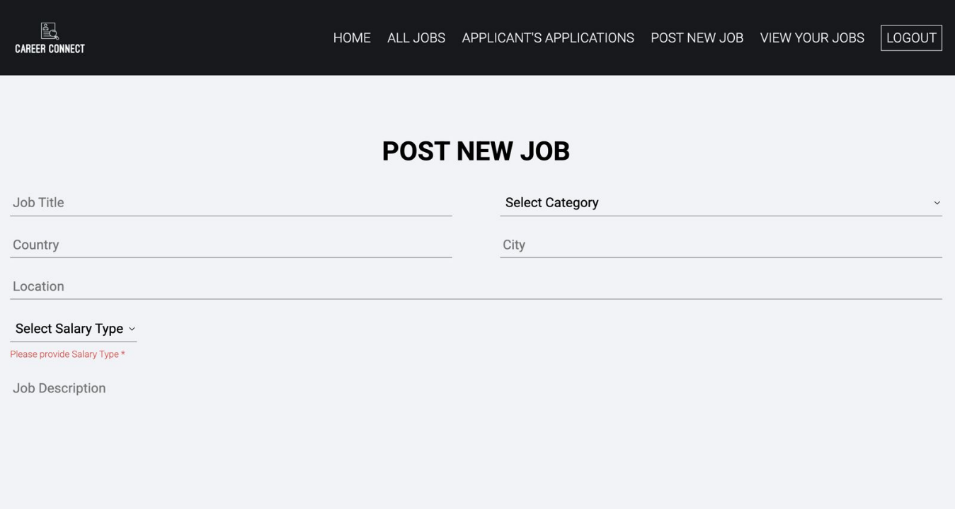

- Home Page

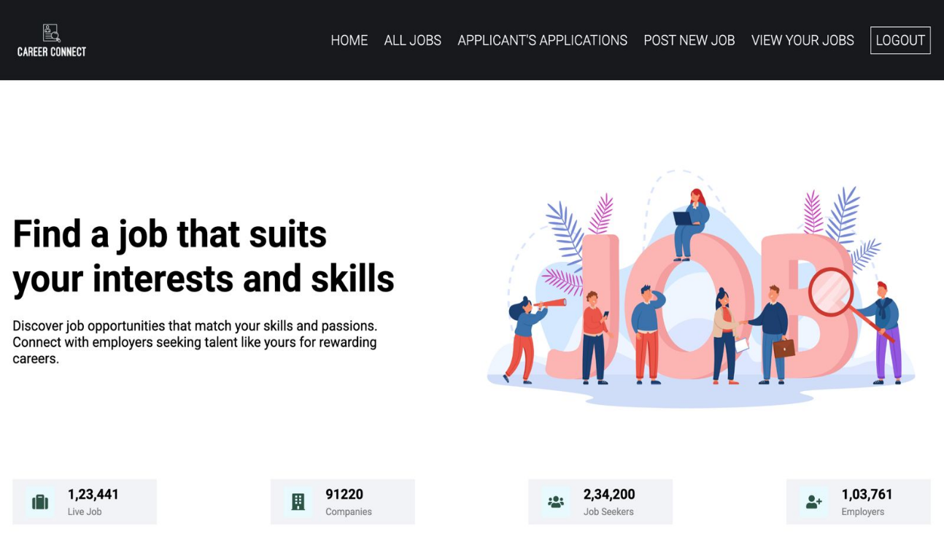

Thanks!

